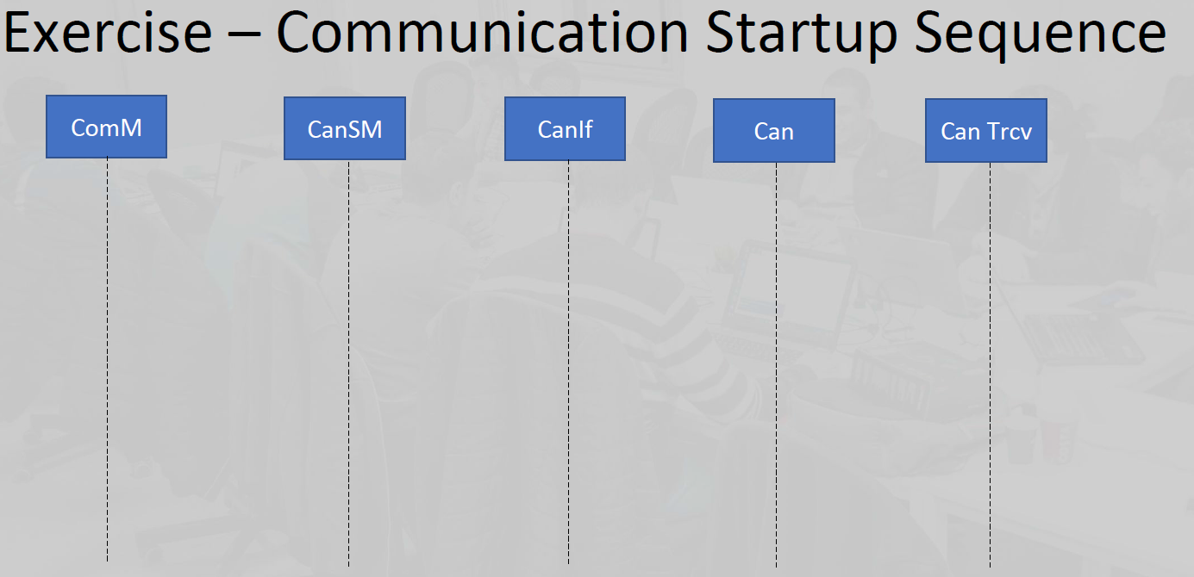

**return**

**Return E_OK**

**request CAN controller mode transition to START()**

**Return E_OK**

**Can_SetControllerMode(Std_ReturnType, uint8,**

**Can_ControllerStateType)**

**Can_SetControllerMode(Std_ReturnType, uint8,**

**Can_ControllerStateType)**

**loop CanSm_StartCanControllerLoop**

**CanIf_SetControllerMode(return, ControllerId,ControllerMode:=CANIF_CS_STARTED)**

**CanIf_SetControllerMode(return, ControllerId,ControllerMode:=CANIF_CS_STARTED)**

**return**

**return**

**return**

**ComM_BusSM_ModeIndication(Channel, ComMode: COMM_FULL_COMMUNICATION )**

**return**

**CanSM_RequestComMode (NetworkHandle, ComM_Mode: COMM_FULL_COMMUNICATION)**

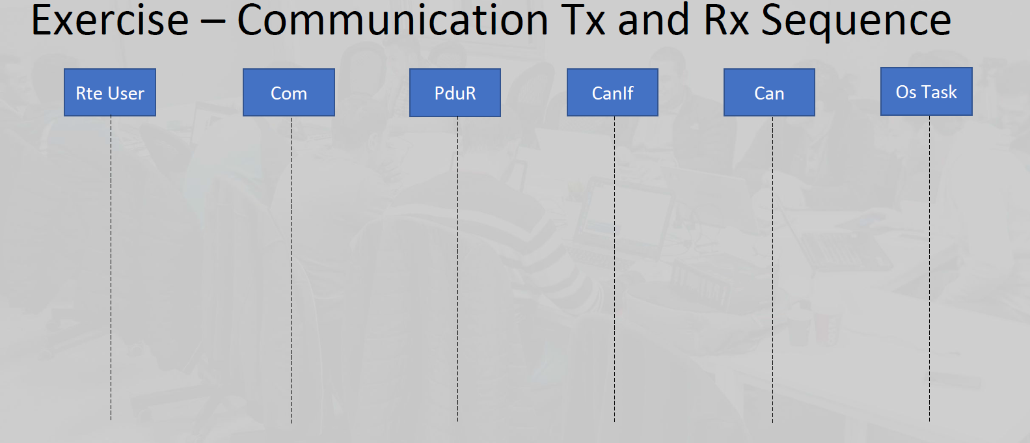

**return**

**Can_MainFunction_Write/**

**Can_MainFunction_Read**

**CanIf_TxConfirmation()/**

**CanIf_RxIndication()**

**CanIf_TxConfirmation()/**

**CanIf_RxIndication().**

**PduR_CanIfRxIndication(PduIdType, const PduInfoType*)/**

**PduR_CanIfTxConfirmation(PduIdType)**

**Can_Write()**

**PduR_CanIfRxIndication()/**

**Can_Write(Std_ReturnType, Can_HwHandleType,**

**const Can_PduType*)**

**CanIf_Transmit(Std_ReturnType, PduIdType, constPduInfoType*)**

**PduR_ComTransmit()**

**PduR_ComTransmit(PduIdType, const PduInfoType*)**

**Com_TxConfirmation(PduIdType, Std_ReturnType) /**

**Com_RxIndication(PduIdType, PduInfoType*)**

**CanIf_Transmit()**

**Copy data to<CanIf> Txbuffer()**

**Internal_processing()**

**Rte_COMCbkTAck_signalX()/**

**Rte_COMCbk_signalX()**

**Rte_COMCbkTAck_signalY() /**

**Rte_COMCbk_signalY()**

**return**

**return**

**return**

**Internal_processing()**